**Name:- Dharan Gowda Superset id:-6387532**

**Create a new React Application with the name “myfirstreact”, Run the application to print “welcome to the first session of React” as heading of that page.**

1. Install Node.js and npm

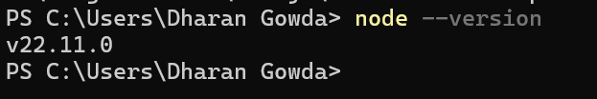

1. Install create-react-app globally

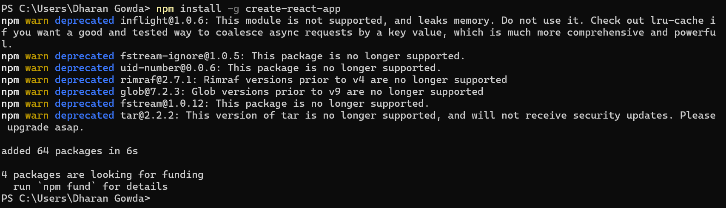

1. Create a new React application

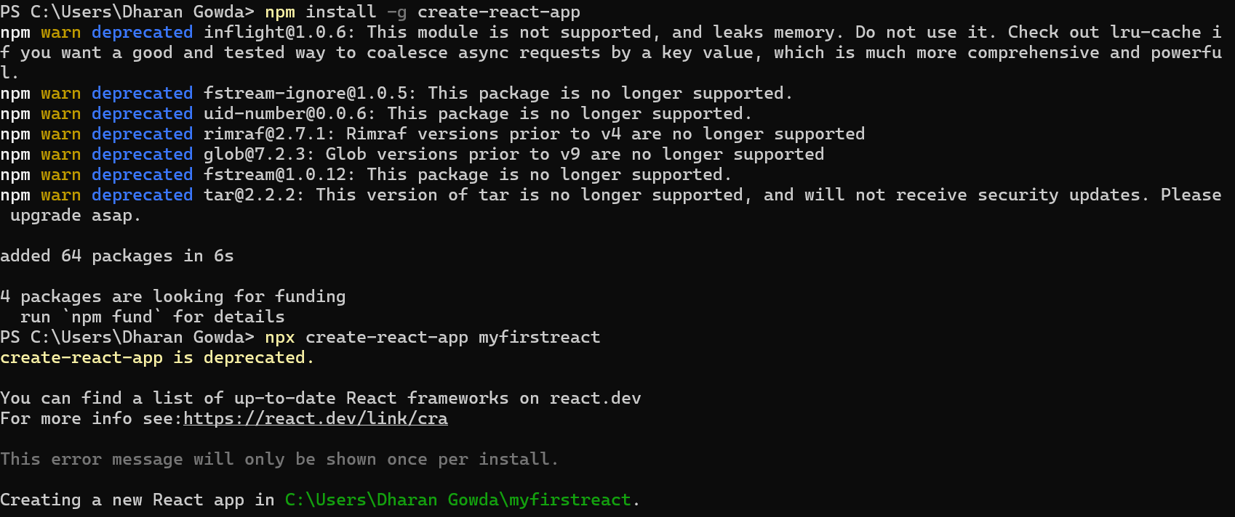

1. Open the project in Visual Studio Code

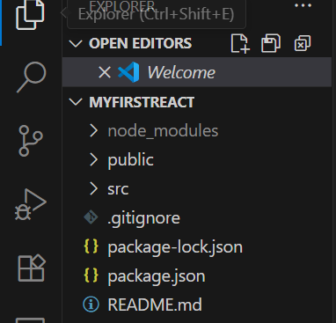

1. Remove all existing code in App.js

*) Replace with the following content

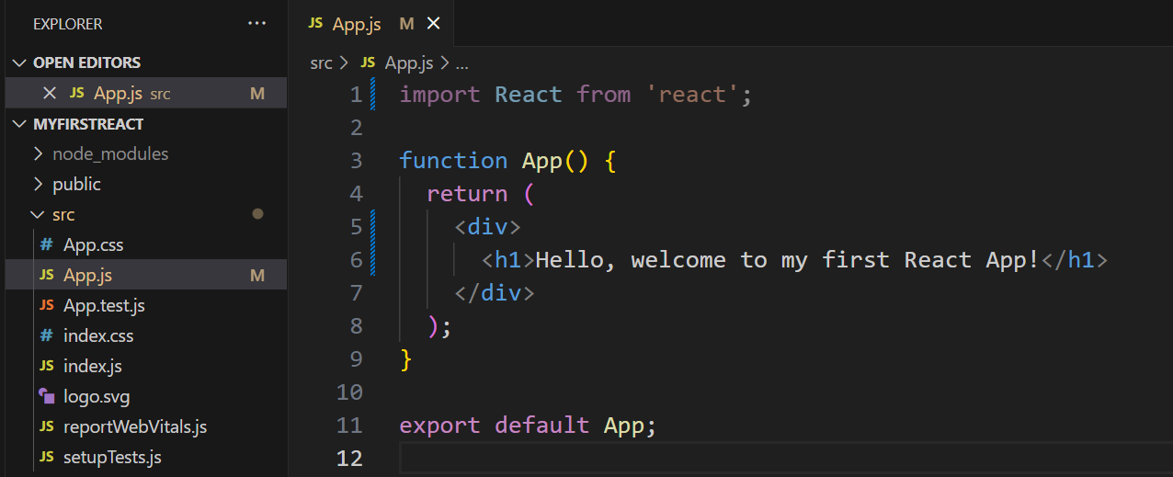

1. Start the React application

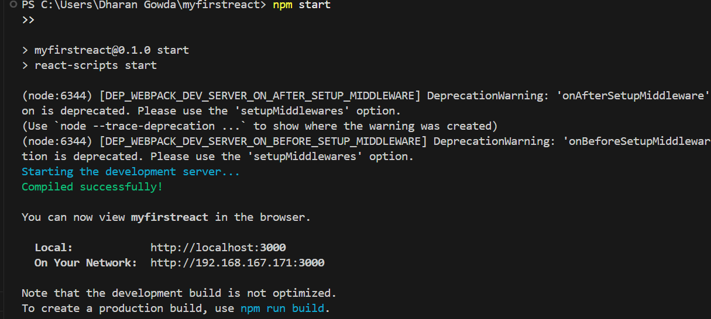

1. View in browser

